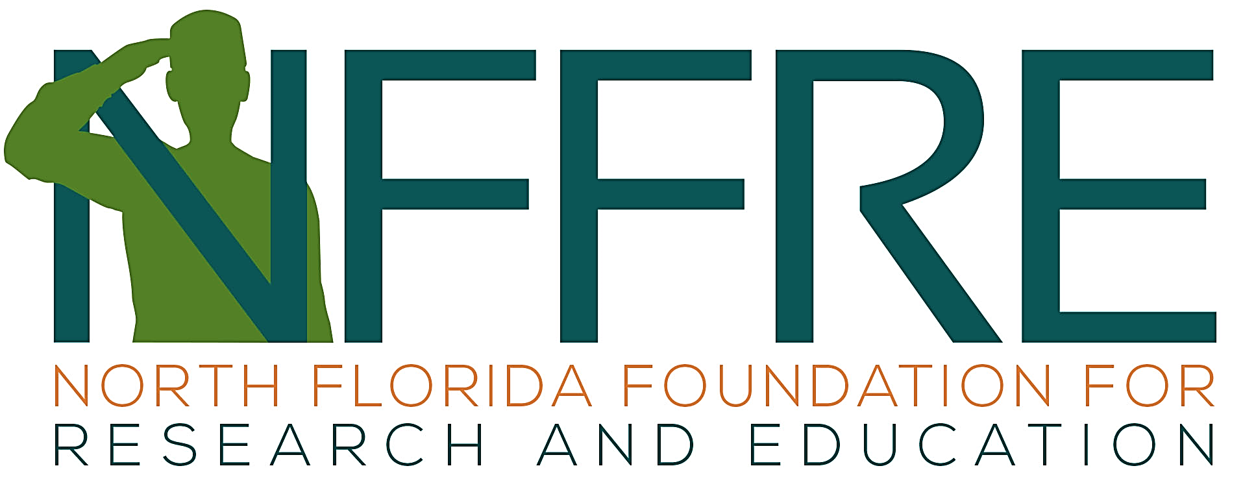
The Gateway to Extramural Funding
For VA Research
nffre-research.org
Contacts NFFRE Executive Director: Angie Smith, Teresa.Smith11@va.gov, 352-548-6448
NFFRE Grant Specialist: EmmaMay@va.gov / VHANFLNFFREAdmin@va.gov
Grant Support Checklist
[ ] Notify NFFRE of grant plans 6 weeks before deadline or sooner for optimal efficiency.
- NFFRE Grant Feasibility Questionnaire (@ Policies & Forms): Submit as soon as possible, again ≥ 6 weeks before deadline.
- Grant agency submission deadline date: .
[ ] Request for Proposal (RFP)/Funding Opportunity Announcement (FOA): Provide PDF or link.
[ ] Principal Investigator(s) [PI] Registrations: For federal grants, 4 weeks before grant deadline, PI should be registered with Grants.gov and/or eRA or, for the Department of Defense grants, eBRAP.
[ ] VA Leadership Letters of Support: Allow ≥ 2 weeks to obtain Check the FOA/RFP first thing to determine whether a letter of support is needed from the ACOS/Research and/or the North Florida/South Georgia VHS Director. NFFRE staff can help with these letters, which should be submitted as soon as possible and should include background info in the form of a draft of the abstract, aims, or research plan as an attachment.
[ ] Budget.
- NFFRE Budget Template/Guide (@ Policies & Forms). This is an Excel file based on the NIH R&R form that includes calculations for NFFRE rates and other related guidance.
- Budget draft: Review with the NFFRE Director as soon as a draft of the budget is done.
- Equipment, materials, supplies: Quotes or other documentation may be needed for some items.
- Subawards / Collaborations involving other organizations
This aspect of the budget must be closely coordinated with NFFRE.
Agreements between NFFRE and state institutions such as the University of Florida or private organizations such as Brooks Rehabilitation can involve the following:
- Conditions that require different forms of agreements such as a consortium, a memorandum of understanding (MOU), or a joint personnel agreement (JPA).
- Constraints by federal regulations, for example, as specified in the NIH policy on consortiums.
[ ] Collaborating Organizations – Other Information
- Prime grantee/organization: Submits the grant and receives the funds.
- Collaboration details
  - Distinguish clearly between activities conducted at VA and at the collaborating organization.
  - Provide contact information for grant administrative staff at the collaborating organization.
- Hiring staff at other organizations: Provide names of key personnel and their department, and research administration staff contact information; base salary and fringe rate are needed.
- University of Florida statistician: The University Florida Dept. of Statistics requires 0.6 calendar months for each budget period.

